Graph Theory - Tutorial 2 Partial Solutions
SMA116 – Discrete Mathematics 1B
Question 1
Write the adjacency matrix for each graph in Figure 1.
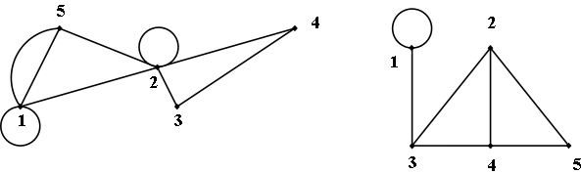
(a)
(b)

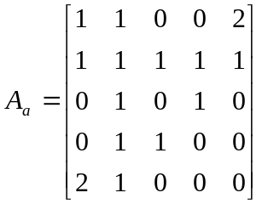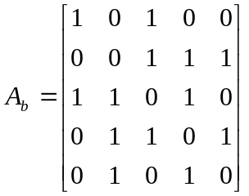

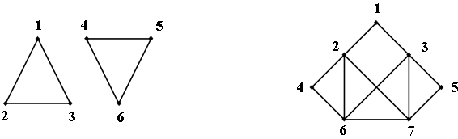
(c)
(d)

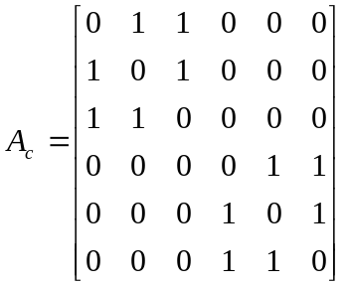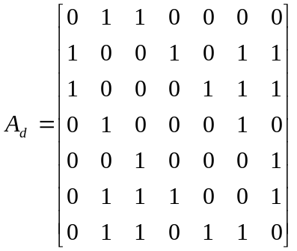

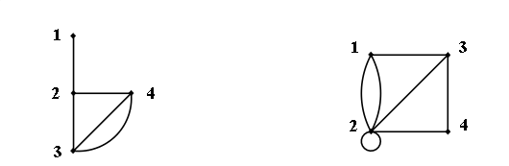
(e)
(f)

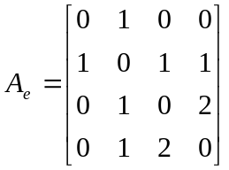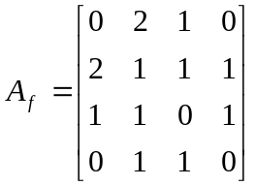
Figure 1
Question 2
For the graph in Figure 1(d), determine 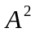 to find the number of paths of length 2 from node 2 to node 6.
Since we are only interested in paths of length 2 between vertices 2 and 6, we only need to calculate 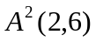. (Note that 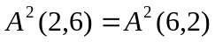 since the matrix is symmetric).
Therefore there are 2 paths of length 2 between vertex 2 and vertex 6. These paths are given by vertex sequences 2,4,6 and 2,7,6.
Question 3
For the graph in Figure 1(a), count the number of paths of length 3 from vertex 5 to vertex 2. Check your answer by calculating 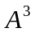.
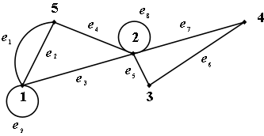

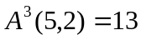 therefore there are 13 paths of length 3 between vertex 5 and vertex 2. These are given below as sequences of vertices and edges. The edges are included in the sequences to differentiate between parallel edges between two vertices.
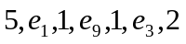 | 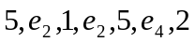 | 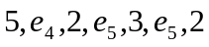
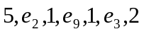 | 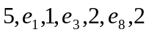 | 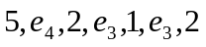
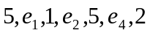 | 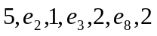 | 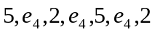
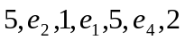 | 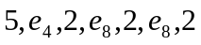
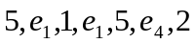 | 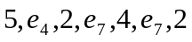

Question 4
The adjacency matrix for an undirected graph is given in lower triangular form by
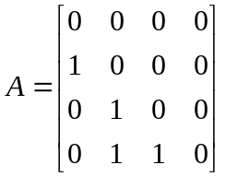
Draw the corresponding graph.
1

2

3
4

Question 6
Draw the undirected graph represented by the adjacency list in Figure 2.

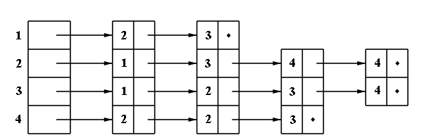

Figure 2
